// 1) input data for 2 students.
#include<stdio.h>
struct student{
char name[50];
int age;
float total_mark;
};
int main(){
struct student a[2];
int i;
for (i=0;i<2;i++){
printf("Enter the name of the student: ");
scanf(" %[^\n]s",a[i].name);
printf("Enter the age of the student: ");
scanf(" %d",&a[i].age);
printf("Enter the total mark of the student: ");
scanf(" %f",&a[i].total_mark);
printf("\n");
}
for (i=0;i<2;i++){
printf("The name of the student : %s\n",a[i].name);
printf("The age of %s : %d\n",a[i].name,a[i].age);
printf("The total mark of %s : %.2f\n\n",a[i].name,a[i].total_mark);

}
return 0;
}
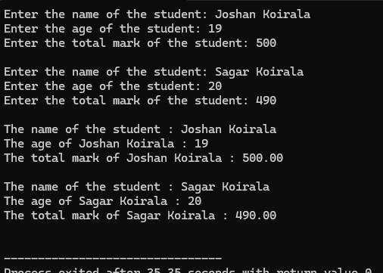
//2) sum of input times.

#include<stdio.h>
struct Time{
int hours;
int minutes;
int seconds;
};
int main() {
struct Time t1, t2, result;
struct Time sum = {0,0,0};
printf("Enter hours for the first time: ");
scanf("%d", &t1.hours);
printf("Enter minutes for the first time: ");
scanf("%d", &t1.minutes);
printf("Enter seconds for the first time: ");
scanf("%d", &t1.seconds);
printf("\n");
printf("Enter hours for the second time: ");
scanf("%d", &t2.hours);
printf("Enter minutes for the second time: ");
scanf("%d", &t2.minutes);
printf("Enter seconds for the second time: ");
scanf("%d", &t2.seconds);
printf("\n");
// operation
sum.seconds = t1.seconds + t2.seconds;
if (sum.seconds >= 60) {
sum.minutes += sum.seconds/60;
sum.seconds = sum.seconds%60;
}
sum.minutes += t1.minutes + t2.minutes;
if (sum.minutes >= 60){
sum.hours += sum.minutes/60;
sum.minutes = sum.minutes%60;
}
sum.hours += t1.hours + t2.hours;
result = sum;
printf ("Sum of the two times:%d hours %d minutes and %d seconds\n",result.hours,result.minutes,result.seconds);
return 0;
}

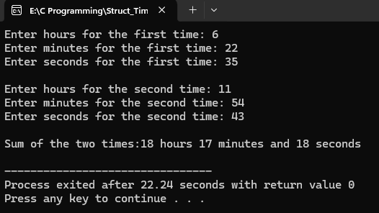

// 3) Book with price between 2000 to 3000 with input of 5 book.
#include<stdio.h>
struct Book{
char title[50];
char author[50];
int price;
}b[5];
int main(){
int i;
for(i=0;i<5;i++){
printf("Enter the title of the book: ");
scanf(" %[^\n]s",b[i].title);
getchar();
printf("Enter the author of the book: ");
scanf(" %[^\n]s",b[i].author);
getchar();
printf("Enter the price of the book: ");
scanf("%d",&b[i].price);
getchar();
printf("\n");
}
printf("Book with price between 2000 and 3000 are:\n");
int found=0;
for(i=0;i<5;i++){
if (b[i].price > 2000 && b[i].price < 3000){
printf("Title: %s, Author: %s, Price: %d\n", b[i].title, b[i].author, b[i].price);
}
found=1;
}

if (!found) {
printf("No books found in this price range.\n");
}
return 0;
}
